Project flow:

Step1- setup github repository and create a folder where we want to store product

Step-3 create a virtual environment

Step-4 – git init

Step-5 – create a readme fiile and add it in github

Step-6 create a requirements.txt and setup.py

Modifiying setup.py

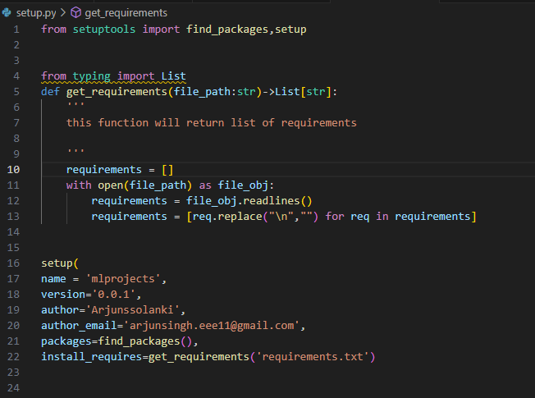

Step-7 src (source) is use to find out how many packages there are create a source folder and put __init__.py in it

Step-8 modify the setup tool 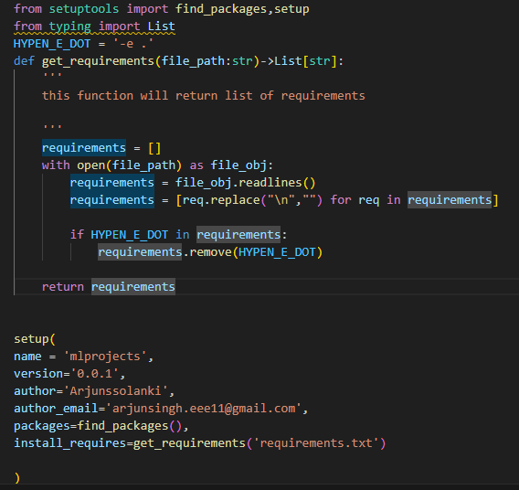

Then in terminal write pip install -r requirements.txt

Poject structure: maximum work is on src (source) folder

Step-1 create a folder name component in src with

__init__.py

Create data_ingestion.py – consist the code like get the data set, split into train and test set

data_tranformation.py- consist all the steps related to data transformation

model_trainer.py – training code, different kinds of model etc

step 2- create a folder name pipeline cosisting in src

training_pipeline.py – consist of training pipeline

prediction_pipeline.py – consit of prediction pipeline

step-3 in src create a logger.py file and exception.py

1. Exception.py-

Now run the file In the terminal



1. Logger.py –

Now we will run the code:

Error occurred : Since logger.py is under src so we need to run it python src/logging.py

New folder is created named log

1. Logger.py -